BANK LOAN REPORT QUERY DOCUMENT

- BANK LOAN REPORT | SUMMARY

KPIs:

Total Loan Applications

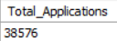

MTD Loan Applications

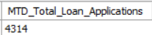

Previous MTD (PMTD) Loan Applications

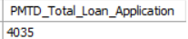

Total Funded Amount

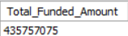

MTD Total Funded Amount

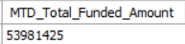

PMTD Funded Amount

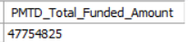

Total Amount Received

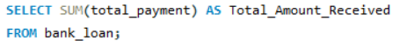

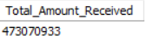

Total Amount Received Month To Date (MTD)

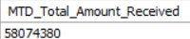

Total Amount Received Month To Date (PMTD)

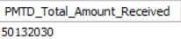

Average Interest Rate

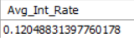

MTD Average Interest Rate

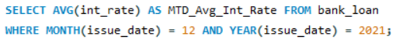

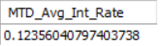

PMTD Average Interest Rate

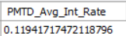

Average Debt To Income Ratio (DTI)

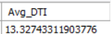

MTD Average DTI

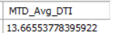

PMTD Average DTI

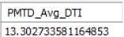

GOOD LOAN ISSUED

Good Loan Percentage

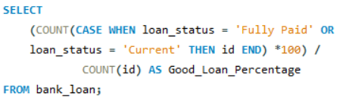

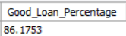

Good Loan Applications

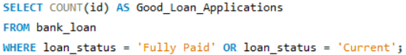

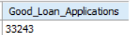

Good Loan Funded Amount

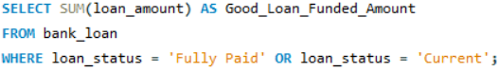

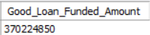

Good Loan Amount Received

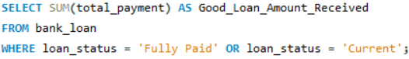

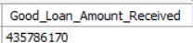

BAD LOAN ISSUED

Bad Loan Percentage

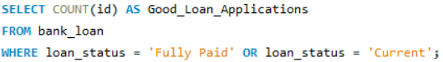

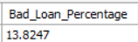

Bad Loan Applications

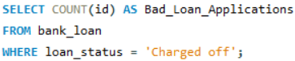

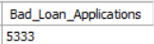

Bad Loan Funded Amount

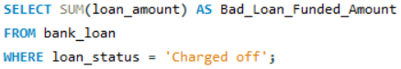

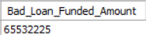

Bad Loan Amount Received

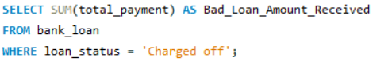

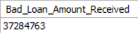

LOAN STATUS
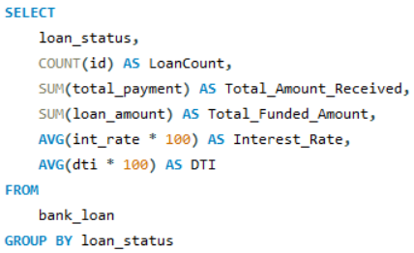

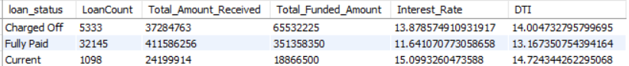

MTD Loan Status

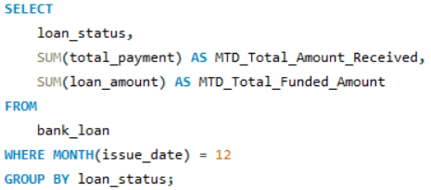

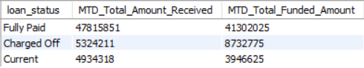

- BANK LOAN REPORT | OVERVIEW

MONTH
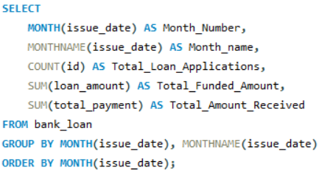

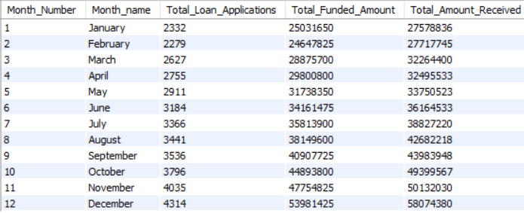

STATE

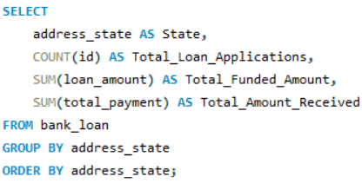

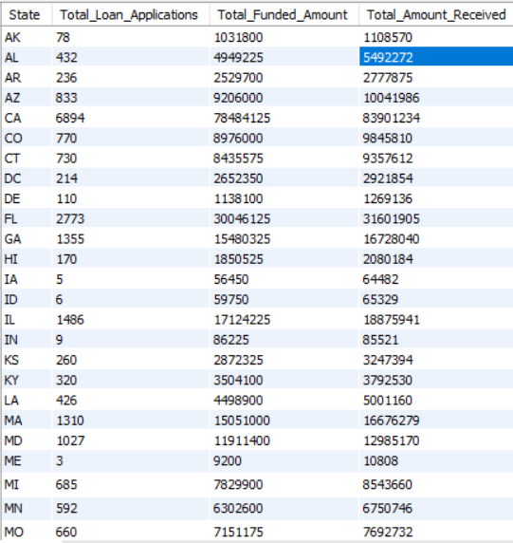
TERM
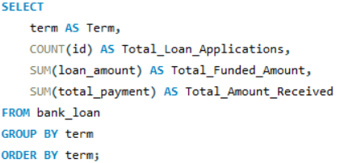

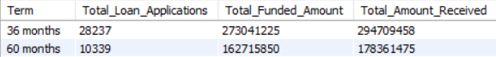

EMPLOYEE LENGTH
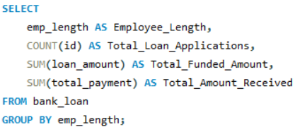

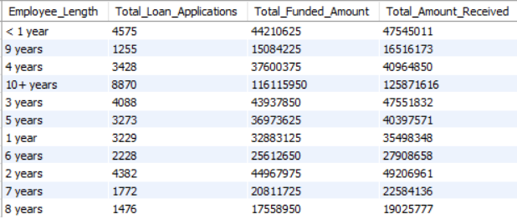
PURPOSE
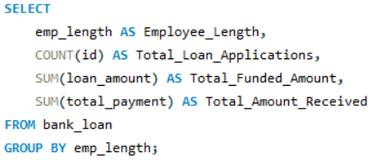

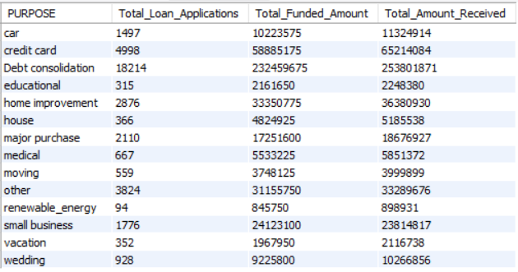
HOME OWNERSHIP
